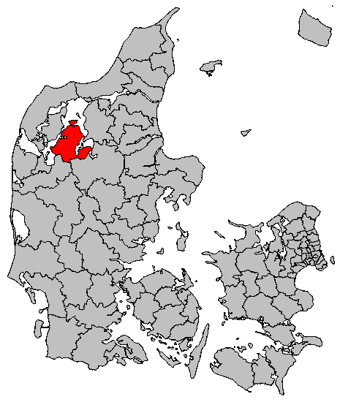
Expression of Interest – Skive Municipality, Central Denmark
Skive Municipality would like to participate in an EU funded project dealing with Smart Mobility Services, i.e. How to reduce CO₂ emissions from the transport sector, reduce congestions, while - at the same time - keeping a high service level and flexibility for the individual commuter.
Background: Skive Municipality is located in the Central Denmark Region, the area is approximately 700 km² and the number of inhabitants around 50.000 (density: 68,1 inh./km²).
Skive Municipality has been working seriously with clean energy and been a frontrunner within sustainability and sustainable energy for decades. In 2008, it was nominated as one of the first Energy Cities in Denmark, in 2012, the municipality signed the CoM, and on several occasions, the City Council decided that Skive should be CO2 neutral (as of 2029).
The Municipality has wide experience in European funded projects in clean energy – both as a partner and a lead partner. However, the transport sector remains a major challenge to deal with.
Project idea: Skive Municipality would like to focus on mobility management, primarily by focusing on citizens’ commuting to the work place (without restraining the issue to this). An EU funded project would give the Municipality the chance to do research into different sustainable mobility services; biking, carpooling, shared cars, integration of private and public transport, MAAS solutions, testing of autonomous vehicles etc. utilizing ICT and ITS in an easy accessible digital solution (taking the form of an app or/and a homepage). The digital system needs to combine already existing platforms with a dimension of private data. Private data could include criminal record, drivers licence, registration and ownership of vehicle. These data will provide a safety aspect for the persons involved in a trip. The solution must also track vehicles and commuters and their expected routes through interactive maps, so it is easy to identify alternatives for the user.
Furthermore, it is necessary to rethink business models within these new mobility services.
Programme and call: Skive Municipality is interested in two Research and Innovation calls within the Horizon2020 2018 - 2020 programme:
- LC-MG-1-2-2018 Sustainable multi-modal inter-urban transport, regional mobility and spatial planning
- LC-MG-1-3-2018 Harnessing and understanding the impacts of changes in urban mobility on policy making by city-led innovation for sustainable urban mobility
Looking for: An already established consortium within this topic that need a public entity to test or make a pilot project within this. Being a municipality, we also have the authority to enable transport demand management tools such as prizing, parking management, low-emission zones etc. It will be important to engage in public, private partnerships getting experience based data through pilots and test for future mobility planning, urban planning, spatial planning and mitigating negative trends within the futuristic mobility solutions and services. This can also be important inputs to developing SUMPs.
Contact details:
Kristoffer Wolsing
Project Manager
Skive Municipality
Tel: +45 20 75 72 98
E-mail: khwo@skivekommune.dk

